MOTEGUARD LOGO COLOR PLACEMENT



1. Move the logo to the center upper.
2. Make the logo Silver and burgundy color
3. Make the logo a little bigger if you can
4. Add the 3 line drop down section to the right of the upper page
5. Add a search engine to the right upper side of the page and the country we are serving
6. Move CONTACT US to one of the drop-down categories from the drop-down list.
7. DROP DOWN LIST should have these main page categories
   1. Company Overview
   2. Markets
   3. Capabilities
   4. Insights
   5. Careers
   6. Investors
   7. Employees
   8. Suppliers
   9. Contact Us
8. Company Overview Subcategories

Company Overview

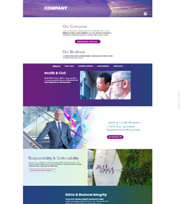

Who We Are

Our Business



Leadership

Responsibility & Sustainability

Ethics & Business Integrity

Partners

Contract Vehicles

Global

History

Markets Subcategories

Markets Overview

Aviation

Defense

Energy & Industry

Government

Healthcare

Homeland Security

Intelligence

Science

1. Capabilities Overview

Capabilities Overview

Trusted AI Mission

Integrated Systems

Mission Operation

1. Insights Overview

Insights Overview

Latest Insights

1. Careers Overview

Careers Overview

Latest Opportunities

Life at Moteguard

Pay & Benefits

Frequently Asked Questions

Careers in Australia

Careers in the UK

HOME PAGE

We need this page to pop up where customers can sign up for our email marketing and solutions. It can have a Facebook connection, but we don’t have a Facebook page yet so give me your feedback.

On the Home Page - We need a video playing in the background for about 2 to 4 minutes

ON THE HOME PAGE THEY WANT SOMETHING LIKE THIS

